Green Belt (6th Gup) Study Guide

This Study Guide is designed to prepare you for your written examination. The answers to the questions below are found in your Student Manual. If you have any questions about the material, be sure to ask an Instructor. You are responsible for anything on previous Study Guides. You are also responsible for reading the Studio (Dojang) newsletter. There may be questions on your test about the articles. This worksheet must be filled out and submitted in order to test.

Terminology

Black Belt Holder ____________________ Black Belt ____________________
Color Belt Holder ____________________ Color Belt ____________________
Jumping Axe Kick ____________________ Spear Hand ____________________
One Step Sparring ____________________ Meditate ____________________
Free Sparring ____________________ Hook Kick ____________________
Low Knife Hand Block ____________________ Wheel Kick ____________________
Middle Knife Hand Block ____________________ Junior Member ____________________
High Knife Hand Block ____________________ Senior Member ____________________

General Knowledge

1. What does the White Belt represent? ________________________________________
2. What does the Orange Belt represent? ________________________________________
3. What numbered Region of the World Tang Soo Do Association is our Studio located? ____
4. What date was the FULL DATE that the World Tang Soo Do Association was founded? _____________
5. Why do we Kihap? ____________________________________________________________
6. What are the Seven Tenets of Tang Soo Do? _______________________________________

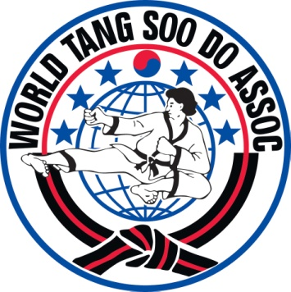
Explain the WTSDA Emblem / Logo / Insignia which is pictured here. You must know 7 things about it.

Forms

Peace and Confidence Form #1 – Pyung Ahn Cho Dan
Creator – Master Anko Itosu
Date Created – 1870
Place Created – Hunan Province, Southern China
Number of Moves – 22
Original Name – Jae Nam

